Successful retail-store v3 homepage Blue/Green rollout
During Blue/Green rollout, Before promoting pods stable:
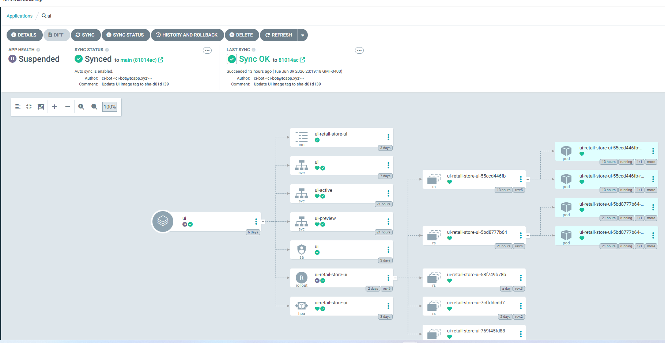
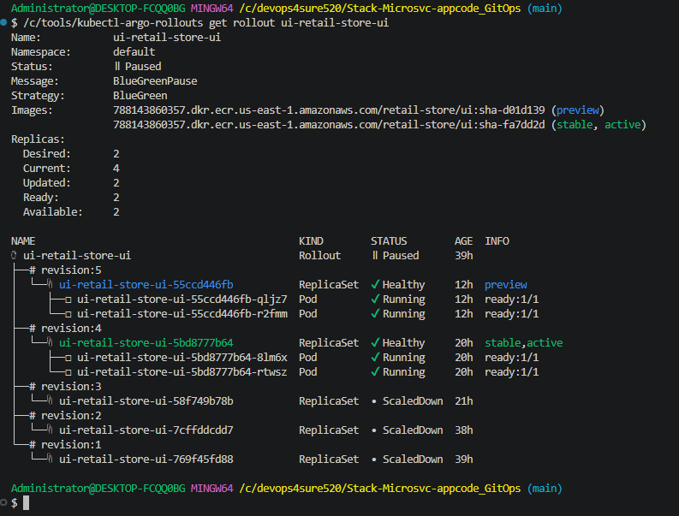
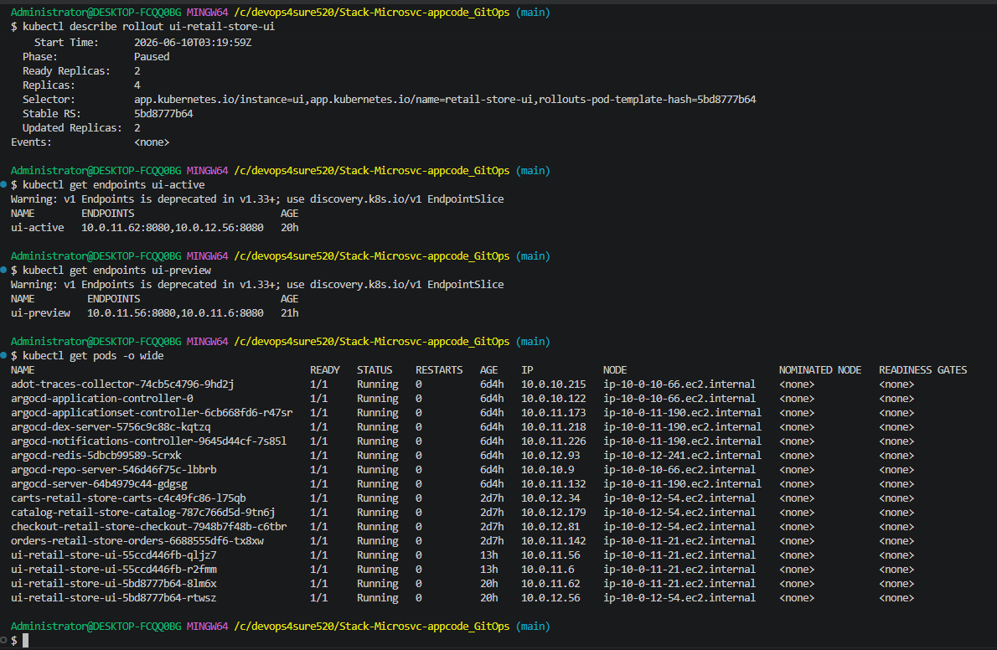

After Blue/Green rollout/promoting:
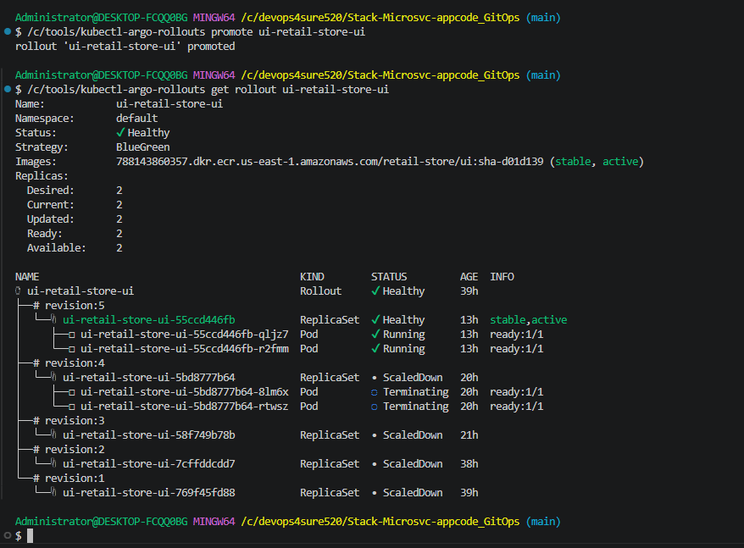

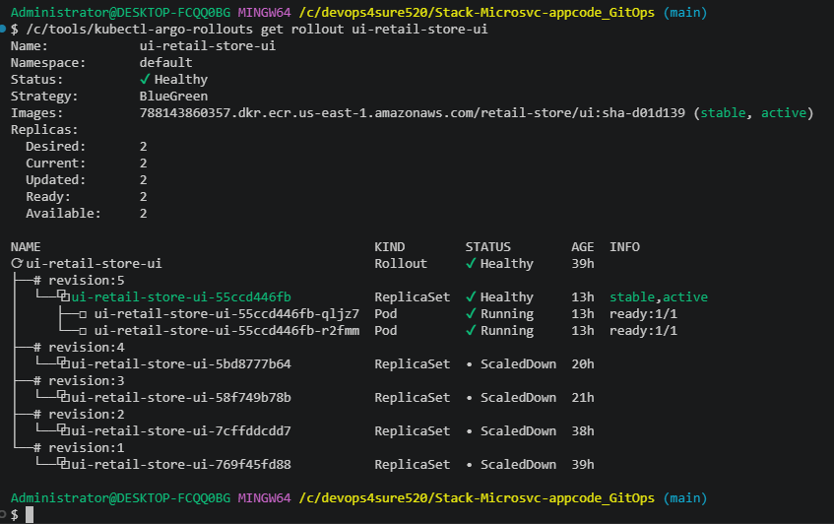
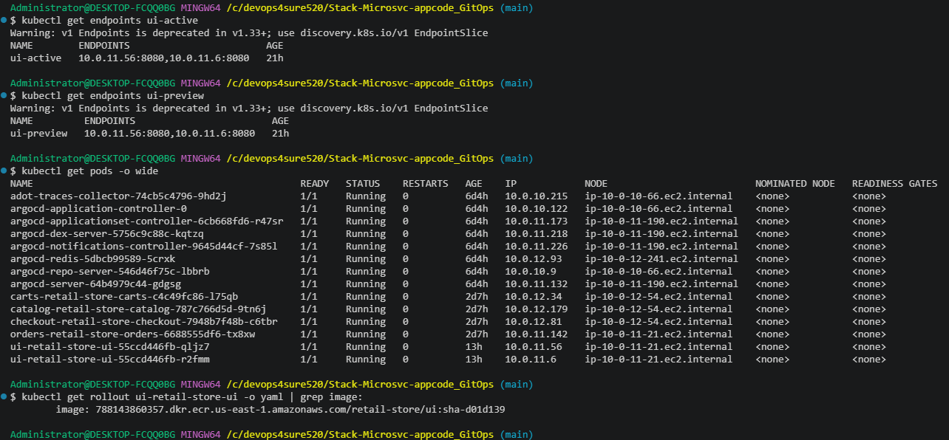
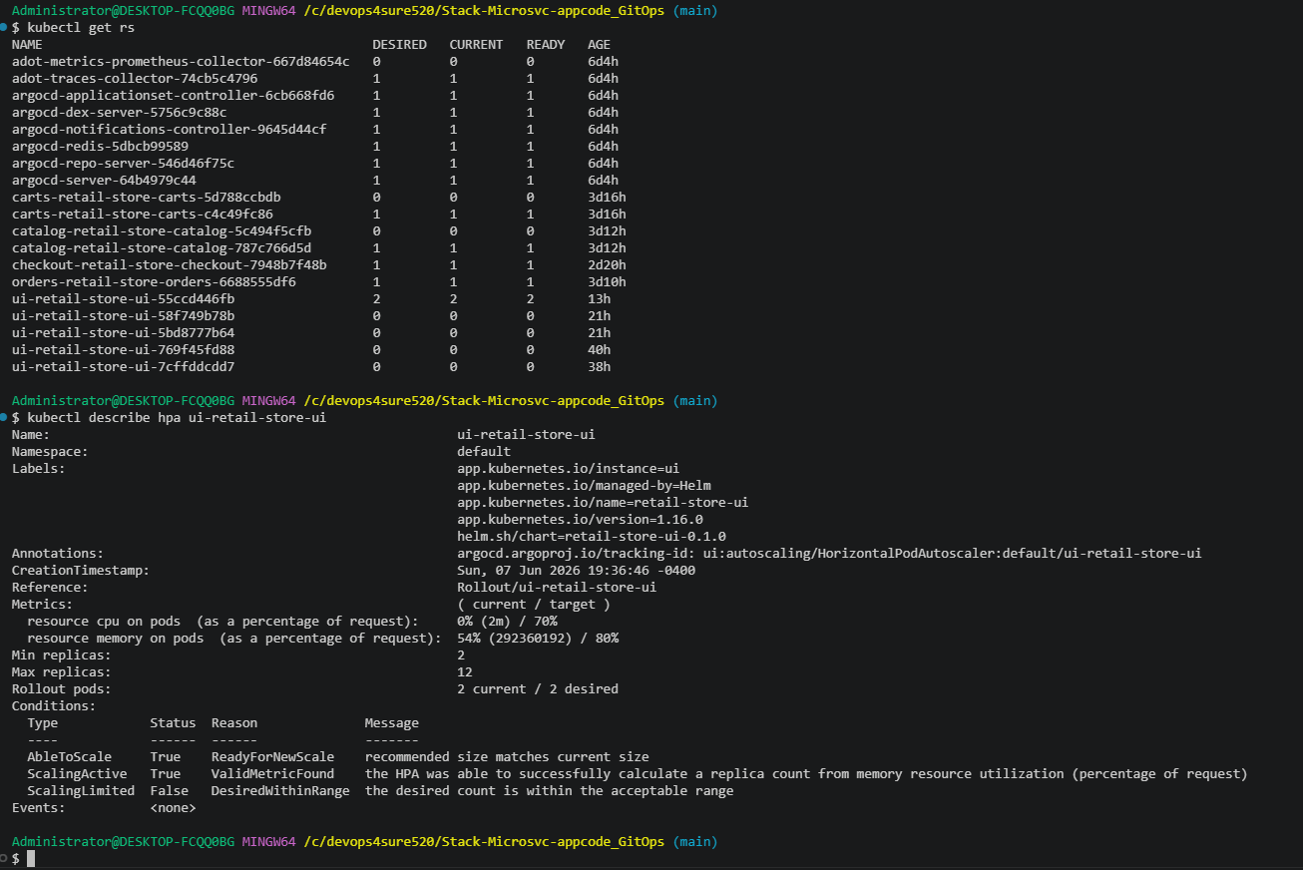
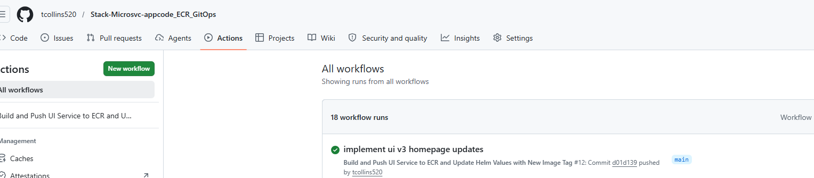
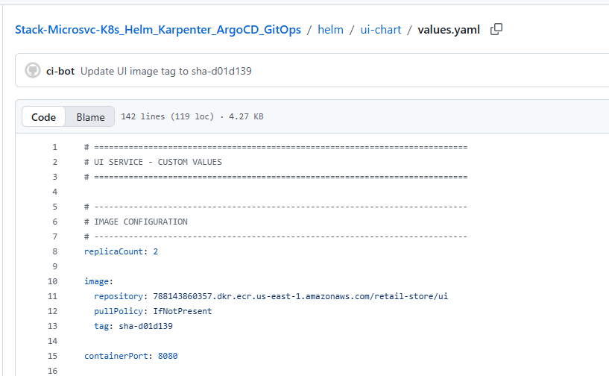

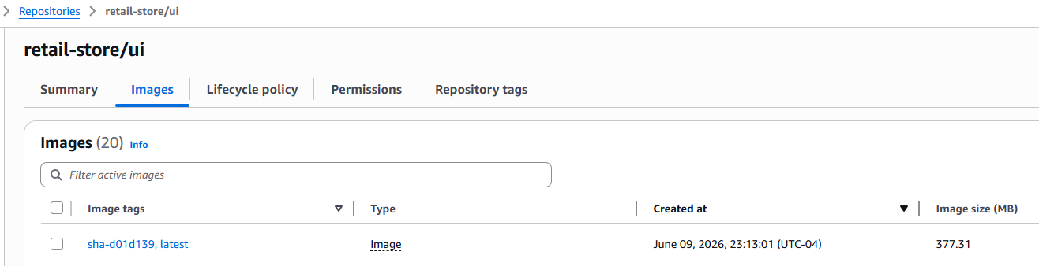
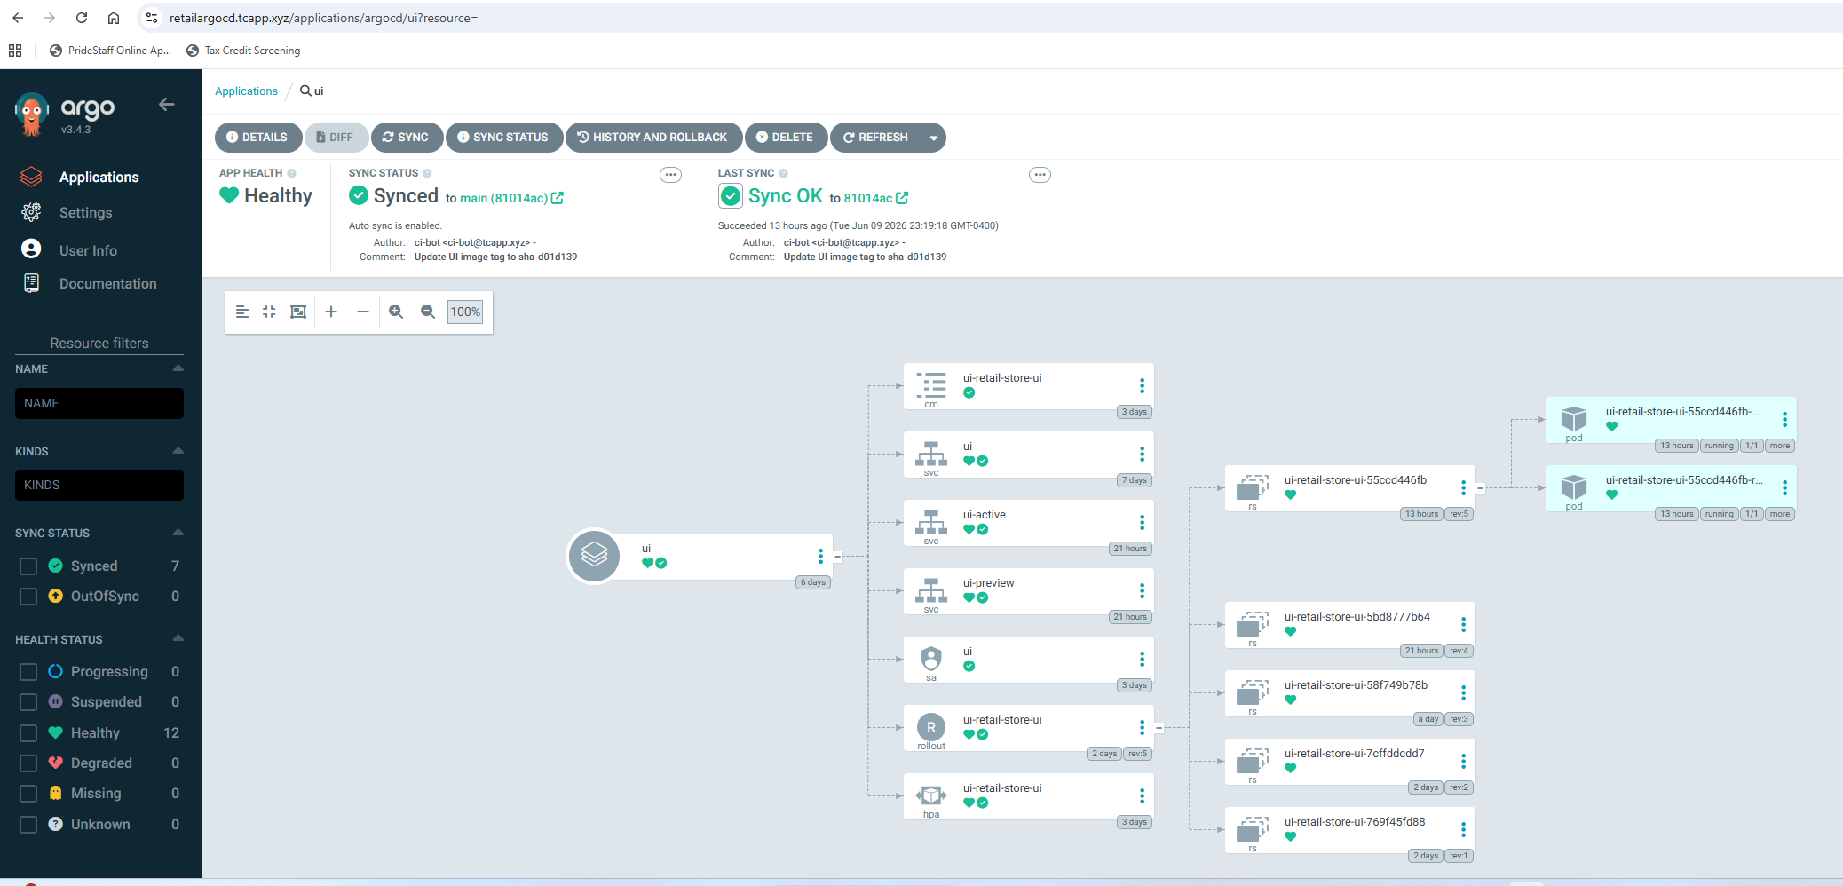

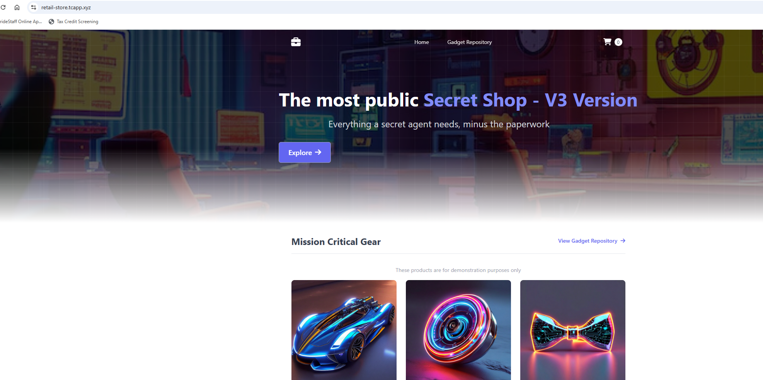
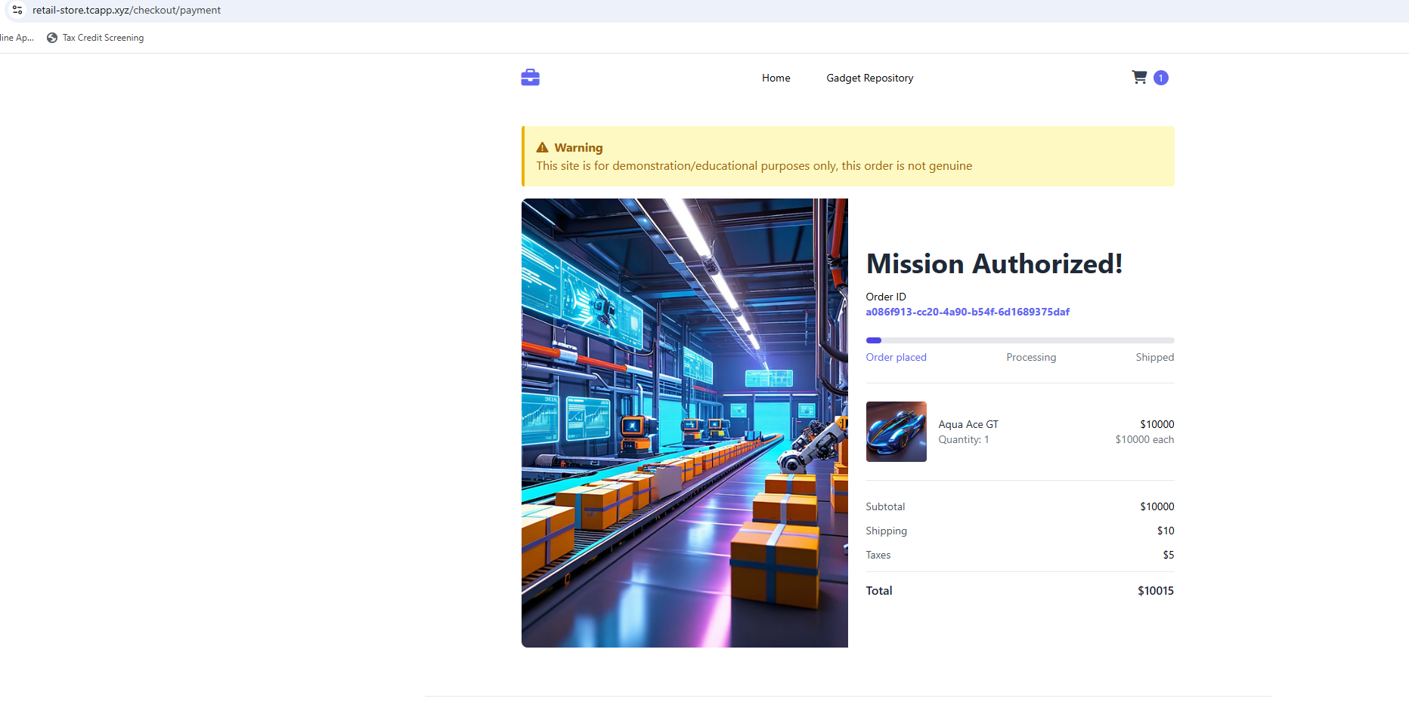
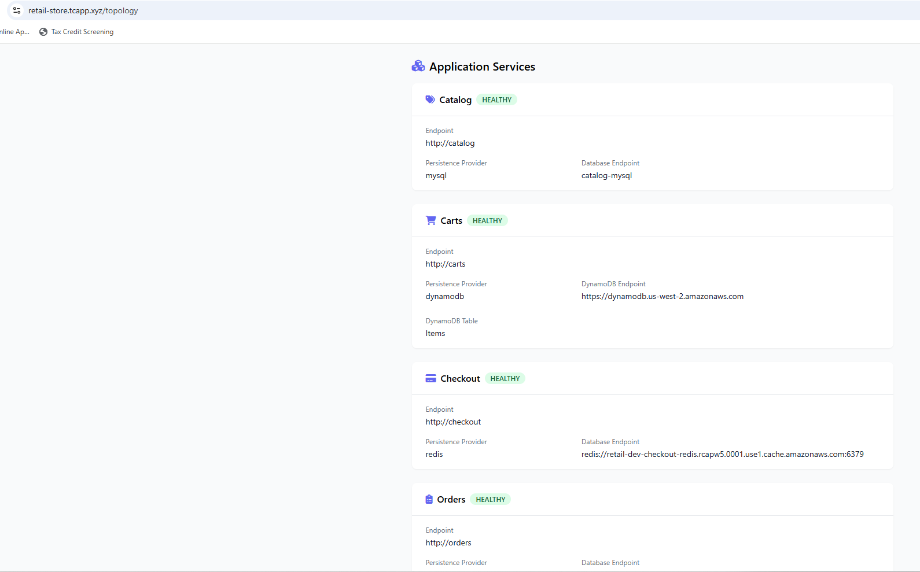
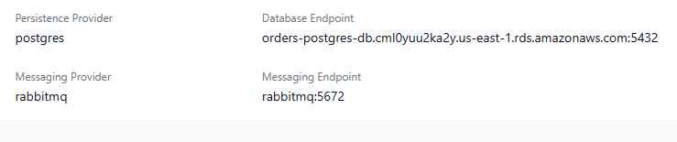

Blue/Green Deployment Summary
Application:
Retail Store UI

Version Promoted:
sha-d01d139

Deployment Strategy:
Argo Rollouts Blue/Green

Promotion Method:
Manual Approval

Container Registry:
Amazon ECR

GitOps:
ArgoCD

CI/CD:
GitHub Actions

Platform:
Amazon EKS

Result:
Successful zero-downtime deployment of UI V3
with validation through preview environment
before production promotion.

